1862
A war against the north has begun. My name is William Forest and I am 24 years old. My wife is Mary Forrest and a soon to be, Nathan William Forest, our expected child, named after my cousin Nathan Forrest. The war has begun and my service has been requested by general lee himself. I, and many of my old friends, have been recruited to be high ranked General officers, in charge of incoming soldiers. I have served four years before, at age 18, in 1854. I returned home for two years, in 1860, and lived peacefully until now.
I must serve my country and protect my land. I will fight too keep slavery legal, for it is the only way my plantation will survive these hard times. I can only imagine the affects of slavery being illegalized. What it would do to our economy. Life would be in ruins.
Starting Monday I will be collecting a group of soldiers, and the marching will begin. But now I must be off.

1866
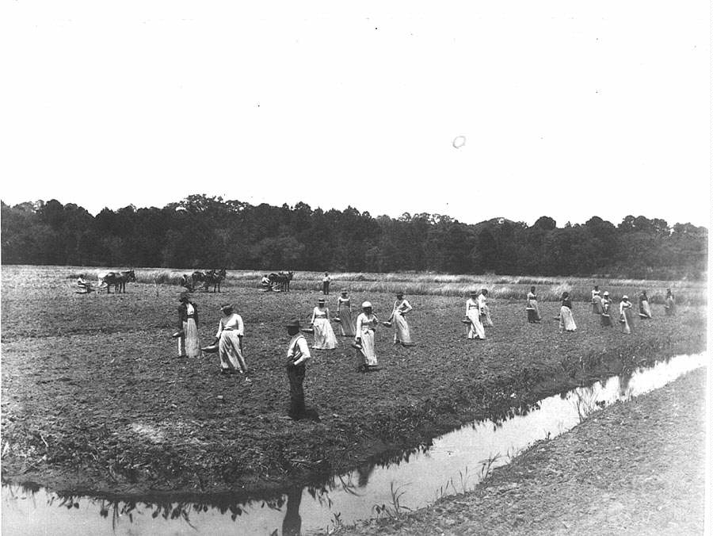
The war has just barley ended at the sound of Lee’s surrender. I have returned to my plantation with haste. I find my 5 year old son, and my incredible wife waiting for me. Already I am hearing rumors of the northern law moving to the south to enforce the new Reconstruction Act. The 13th amendment is being set into affect. This amendment abolishes slavery. I do not expect to be able to keep my plantation profitable without slaves. I am infuriated by this new idea. Slavery is our right, and should not be taken away from us. I must stay calm. But as the times get harder, so does my judgment. I am a church going Christian, I know the law and obey it. Slavery should be our decision. Since the reconstruction has started my own neighboring plantation owners have sold their land because of slavery being outlawed. The northern enforcements have moved in and given the plantation owners the option to free the slaves or be arrested. This is an outrage. This is like sacrificing my life to them, how will I ever survive with no one to work? Life without slavery has become much worse, and I know not what to do. I have given my slaves the option to leave the plantation yet most of them stay for a low wage. They have no where to go, if they are not owned they will only because homeless men crowding and sleeping on the streets. How can this new life be any better then before the war? Well it isn’t. My cousin has sent me a request to join his group. He calls it the Ku Klux Clan or KKK for short. He describes it as a riot group. He and the member meet then protest against authority, he says it’s easier to fight when you have big numbers and encourages me to join. I am still unsure about it, I would not want to hurt or dishonor my family, but drastic times call for drastic measures.

1869
The 14th amendment has been set into affect. This amendment gives former slaves the title of free Americans. They have now become citizens according to this amendment. I have joined my cousins KKK group, and now we meet every Wednesday and Saturday to plot against authority. We go on night raids through small towns, burning crosses in front of peoples’ houses. We bombard the black residents, and throw things at them and yell profane words. Sometimes we even tie them to trees and such, and torture them until they confess to being our slave. Then we leave them there until one of their friends is brave enough to save them. There is about 40 members in the group now. Some or most of us ride on horse back covered in white robes. Towns are left devastated by the destruction when we have passed. There is no better way to get back at the government for this treachery. We will continue
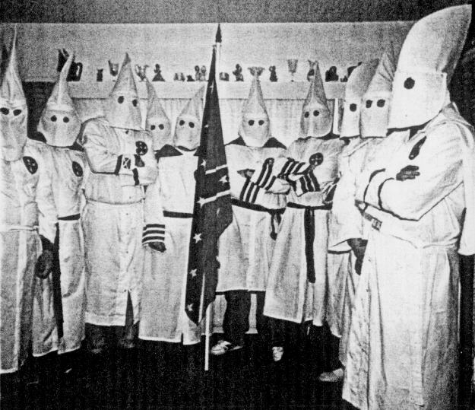
Aside from the KKK my boy is 9 years of age now. My former slaves would protest against me if they knew what I do during the night. I try to keep my membership in the KKK a mystery to anyone who asks. My wife does not disapprove of it, instead only tells me to be careful. She tells me every day and night how terrible upset she would be if anything ever happened. During the days I spend at home however I work on the plantation with my former slaves. I pay them still and small wage, just enough to keep them from leaving. But I never raise the wage unless I see improvement in their work. I wake them early in the morning before the sun rises. We go out together and prepare for harvesting. I return for breakfast in my home when my boy awakes. Then he comes to join me. The workers get fed around lunch time, just before the blazing sun is over head. This gives them time out of the heat when it is hottest. Then it is back to work until nightfall. On Sundays we rest. The workers do not join us in church. Instead they have their own church further up in town. We however attend the community church.
That is all my week consists of, and it is the same every week. It has been that way since the war. And life will continue.

1870
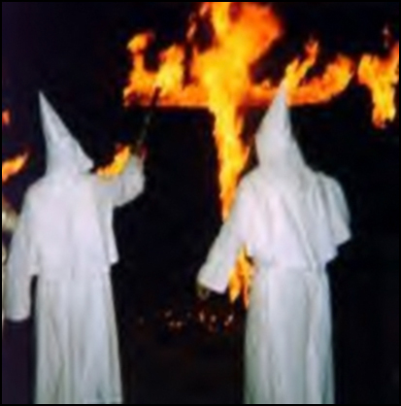
My boy has just turned 10 years old and is getting very strong. We work in the fields together without a worry in the world, other then the 15th amendment that has just been issued. It gives former slaves the right to vote. This has angered the rest of my clan and I. The KKK now takes friendly strolls down the streets of the state capital building burning whatever gets in out way. We are led by a flaming cross. Everywhere we see segregation as we pass by, which is good because then we only have to burn down one side of the street. We enter restaurants and pull blacks out of their seats and throw them into the streets. The police of course try to stop us, and many members have been shot. The group consists now of about 100 members at any given time. Just as we think to many members have been arrested to keep protesting, more show up in brilliant white cloths on horse back. But raiding the small towns is the least of our worries. Since the 15th amendment, blacks can vote for anyone that will protect them. This is very bad for us clan members. So in retaliation we have started burning down local black schools and voting centers. We burn them down and beat up any black in the area and hope they don’t come back and vote next time. I don’t think this madness will ever end. It could have all been prevented.

1872
Since the war blacks have been free to roam wherever they please. If it were up to me they would be kept in cages like the animals they are. They are not people. Just because they can’t walk and somewhat speak, with their queer accents. They are the ones that should be thrown in jail. All they do is get in the way and crowd white places. I can hardly get anywhere without then getting in my way. Segregation is the only benefit the southern white population has against them. They are forced to drink out of separate water fountains. We’re to afraid their diseases might spread. The children go to different schools. They eat in different parts of the restaurants. And thank the lord they are even forced to the back of the public busses. I still ride with the KKK. I ride proud. I’m proud to be apart of a group who feel the same way I do. There are always people in white around trying to recruit more members. The stronger the group is the angrier the government gets. The clan has started fighting off the northern enforcement. We have ridden with our burning cross pass neighborhoods where we make marks in the land. The government has forced slave owners to give up their land to slaves. Now we burn those lands, on our way to burning the northern enforcement. When we meet a challenger we circle around them and yell profane things at them. Since our numbers are so great now, they are usually scared off and sent running. When we meet the law, such as police, we stand still. They usually try to arrest some, but they can never take us all. Other then the KKK the riots have settled. Some ‘equality’ groups have tried to un-segregate schools and other public areas. Their attempts have been futile. These times will never end.

1874
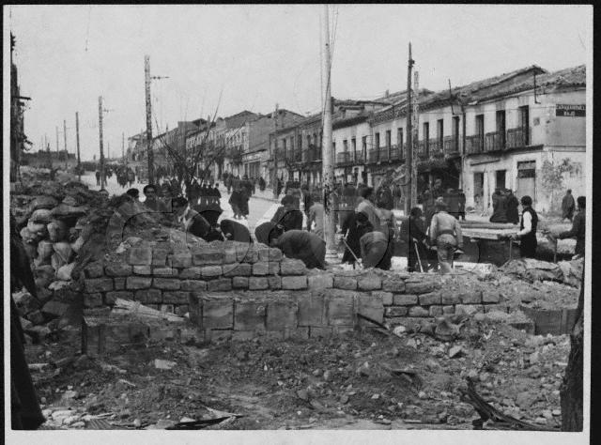
Since my last entry, much has changed. I last wrote ‘times will never change’ but they have. Slavery is almost completely diminished. There are no more riots. The proud members of the KKK are starting to go separate ways now. They no longer terrorize the streets, but instead wait patiently for an antagonist to come to them. When one does then there is trouble. It is usually ended by police showing up on the scene and breaking up the fight. Black people are now speaking out. They used to be unpaid slaves. Then they were free men constantly being fought and discriminated against. And now they vote. Take part in public activity. Yet still segregated they are being treated like people instead of animals. Yes times changes a lot. I am no longer a member of the KKK. My cousin has been to jail 3 times before, and is there now. I have left their group of raids and do not miss it. I spend for time with my 12 year old boy. He does well in school. And is becomes a huge help in work at home. I have settled down now at age 34, along with my incredible wife. Life has changed, some for the worse, some for the better. But it goes on...

